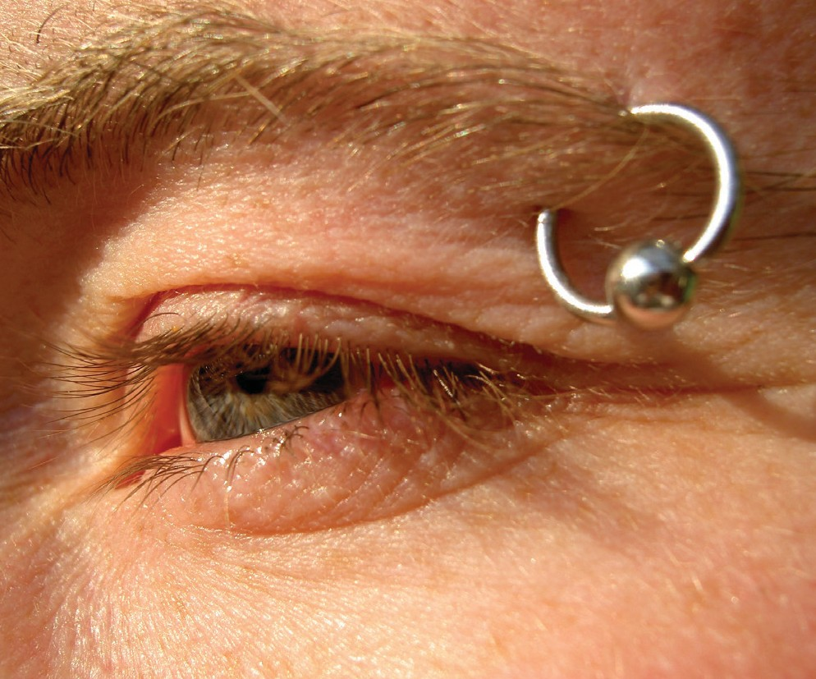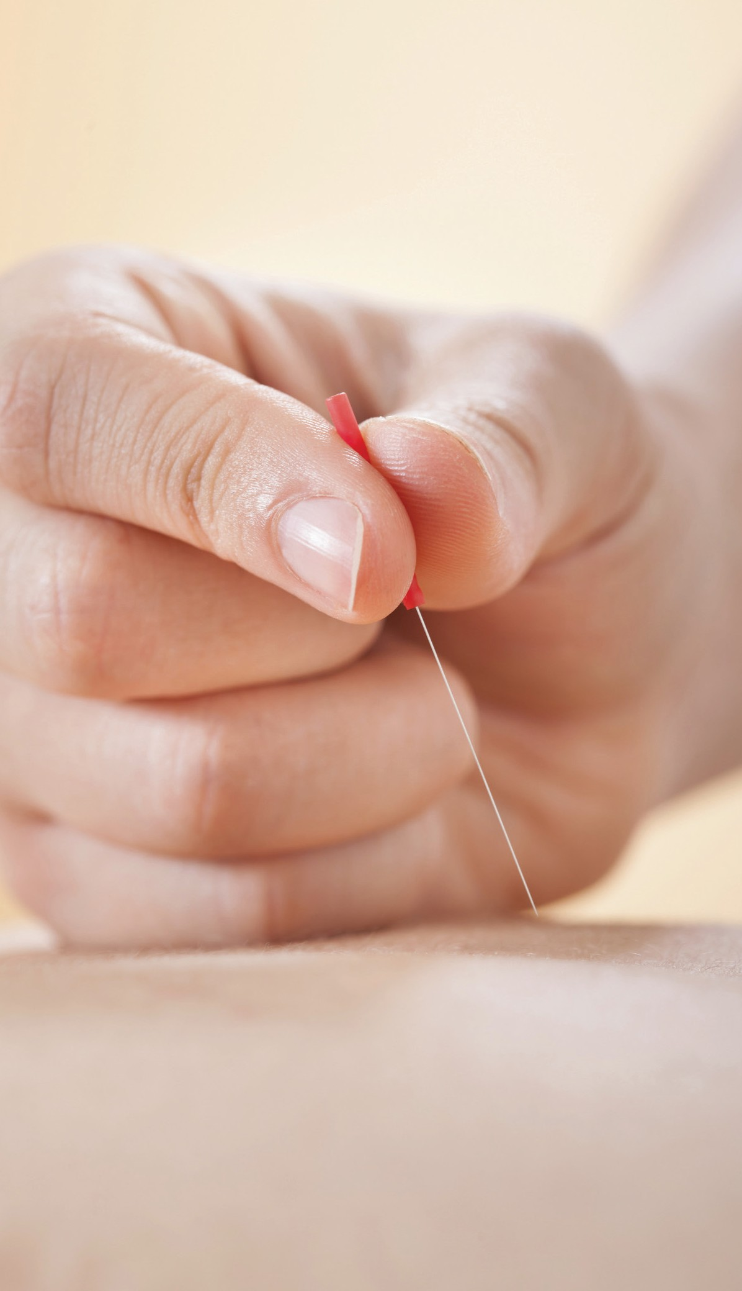***Kent Code of Practice for Hygienic Skin Piercing***

## Kent Councils working together

Contact

You should consult your local authority to find out about registering for skin piercing procedures, and to obtain a copy of their byelaws.

Local authorities and organisations participating in this code of practice are listed below:

* Ashford Borough Council, Civic Centre, Tannery Lane, Ashford, Kent TN23 1PL Tel: 01233 331111
* Canterbury City Council, Military Road, Canterbury CT1 1YW Tel: 01227 862000
* Dartford Borough Council, Civic Centre, Home Gardens, Dartford, Kent DA1 1DR Tel: 01322 343434
* Dover District Council, White Cliffs Business Park, Dover, Kent CT16 3PJ Tel: 01304 821199
* Gravesham Borough Council, Civic Centre, Windmill Street, Gravesend, Kent DA12 1AU Tel: 01474 564422
* Maidstone Borough Council, Swale House, East Street, Sittingbourne, Kent ME10 3HT Tel: 01795 417850 Email: [environmentalhealthadminSBC_MBC@midkent.gov.uk](mailto:environmentalhealthadminSBC_MBC@midkent.gov.uk)
* Medway Council, Gun Wharf, Dock Road, Chatham, Kent ME4 4TR Tel: 01634 306000/01634 333333
* Sevenoaks District Council, Council Offices, Argyle Road, Sevenoaks, Kent TN13 1HG Tel: 01732 227000
* Shepway District Council, The Civic Centre, Castle Hill Avenue, Folkestone, Kent CT20 2QY Tel: 01303 853000
* Swale Borough Council, Swale House, East Street, Sittingbourne, Kent ME10 3HT Tel: 01795 417850 Email: [environmentalhealthadminSBC_MBC@midkent.gov.uk](mailto:environmentalhealthadminSBC_MBC@midkent.gov.uk)
* Thanet District Council, PO Box 9, Cecil Street, Margate, Kent CT9 1XZ Tel: 01843 577000
* Tonbridge & Malling Borough Council, Gibson Building, Gibson Drive, Kings Hill, West Malling, Kent ME19 4LZ

Tel: 01732 844522

* Tunbridge Wells Borough Council, Town Hall, Royal Tunbridge Wells, Kent TN1 1RS

Tel: 01892 526121 Email: [environmentalhealthadmintunbridgewells@midkent.gov.uk](mailto:environmentalhealthadmintunbridgewells@midkent.gov.uk)

* Tattoo and Piercing Industry Union, GMB, 152 Brent Street, Hendon, NW4 2DP Email: [info@tpiu.org.uk](mailto:info@tpiu.org.uk)

Issue date:

References

This document has been produced with reference to the following sources, and in consultation with the Tattoo and Piercing Industry Union:

* Tattoo and Body Piercing Guidance Toolkit, endorsed by Chartered Institute of Environmental Health (CIEH), Public Health England (PHE), Health and Safety Laboratory (HSL) and Tattoo and Piercing Industry Union (TPIU) - [*http://www.cieh.org/WorkArea/showcontent.aspx?id=47704*](http://www.cieh.org/WorkArea/showcontent.aspx?id=47704)
* Health Protection Agency (Kent Health Protection Unit Guidelines)
* Barbour Index/Chartered Institute of Environmental Health

(Body art, cosmetic therapies and other special treatments, ISBN 1-902423-80-1)

* Medicines and Healthcare Products Regulatory Agency

Benchtop Steam Sterilisers – Guidance on Purchase, Operation and Maintenance, ISBN 1-84182-615-4

* Health and Safety Executive

Pressure Systems – safety and you (Pressure Systems Safety Regulations 2000) leaflet ref INDG261(rev1) - [*http://www.hse.gov.uk/pubns/psindex.htm*](http://www.hse.gov.uk/pubns/psindex.htm)

* SR12 COSHH Essentials – Electrolysis, piercing, tattooing and micropigmentation - [*http://www.*](http://www/) *coshh-essentials.org.uk/assets/live/SR12.pdf*

Background

Under the Health and Safety at Work etc Act 1974, there is a duty for anyone at work to ensure that they and other persons on the premises are not placed at any avoidable risk, so far as is reasonably practicable. There is also a duty on employers to ensure that employees are properly trained and proficient in the procedures required for working safely. This includes procedures for working with substances hazardous to health (pathogenic microorganisms as well as hazardous chemicals used for cleaning or inks used in tattooing).

This document was originally produced by Dartford Borough Council in January 2009. It aims to assist both practitioners and enforcers by presenting expected minimum standards as well as best practice in a user friendly format. It also aims to provide guidance on establishing competency, particularly where accredited training programmes are not available.

In consultation with the participating authorities and the Tattoo and Piercing Industry Union, this document has been reviewed and updated, and can be used in conjunction with the Tattoo and Body Piercing Guidance Toolkit (July 2013).

Contents

Page number

1. Introduction 4
2. Training and competency 6
3. Micro-organisms and the chain of infection 9
4. Customer care and record keeping 11
5. Skin preparation before a skin piercing procedure 13
6. Personal cleanliness of operator 14
7. Personal protective equipment (PPE) 15
8. Constructional standards 17
9. Cleanliness of premises and fixtures 18
10. Hand-washing facilities 18
11. Maintaining a clean environment 19
12. Cleaning and decontamination 21
13. Sterilisation 24
14. Single-use items 28
15. Sharps 29
16. Dyes/pigments 30
17. Blood/body fluid spillages 30
18. Uses of sodium hypochlorite (bleach) and strengths of solution 32
19. Needle-stick injury or splash from blood or body fluids 33
20. Disposal of waste 34
21. Ear-piercing 36
22. Cosmetic body piercing 37
23. Mobile/home working 37
24. Insurance 37
25. Legal references – list 37

Appendix 1 – Guidance on the medical questionnaire / client consent form 38

Appendix 2 – Aftercare follow-up – evaluation sheet 41

Appendix 3 – Aftercare of client 42

Appendix 4 – Use of local anaesthetics 43

Appendix 5 – Hand hygiene 44

Appendix 6 – Chemical cleaning and disinfection 46

Appendix 7 – Example maintenance record sheet 48

Appendix 8 – Vaccinations 49

# Introduction

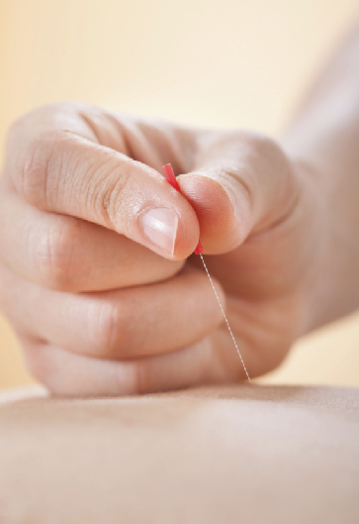This code of practice sets out procedures and practices that are considered necessary to comply with legal obligations under various legislation applicable to hygienic skin piercing. Alternative

procedures and practices may be acceptable, but only if they achieve the same effect in controlling the risks to health. Only the courts can give definitive interpretation of the law.

If you operate a business which involves the practice of puncturing or piercing the skin or flesh of the human body, then this code of practice applies. Skin piercing and puncturing includes:

* Acupuncture;
* Ear-piercing;
* Electrolysis;
* Cosmetic piercing;
* Tattooing; and
* Semi-permanent skin colouring (micropigmentation, semi-permanent make-up and temporary tattooing).

There may be other activities being carried out that are not covered under Local Government (Miscellaneous Provisions) Act 1982 (as amended) - for example, derma rolling, branding, scarification or other body modifications, etc. Although these activities do not currently require registration, the principles set out in this code of practice can still be applied.

If your local authority has adopted byelaws under the Local Government (Miscellaneous Provisions) Act 1982, as amended by the Local Government Act 2003, then you will be required to register with them before carrying out skin piercing activities. Normally, the premises where the activity is carried out and each person who provides the treatment must be registered with the council in the borough within which you operate (if this is more than one, then you are required to register with each one). Different councils have different ways of administering this, so you will need to check. You will also need to notify your local authority if you move premises or if there are any changes to the therapists/practitioners working at the premises.

London Authorities also have enforcement powers under the London Local Authorities Act 1991, which covers Massage and Special Treatments Licences. It has similar parameters to the

registration and byelaws mentioned above but has a renewal aspect unlike the registration system described.

Registration or licensing (whichever is applicable) is important to ensure that you are operating within controlled conditions, to reduce the risk of introducing micro-organisms that can cause localised or blood-borne infection, which in some cases has resulted in death. Both aim to ensure the protection of health for both client and practitioner.

Regardless of registration or licensing, you have responsibilities under the Health and Safety at Work etc Act 1974 towards anyone who may be affected by what you do. This will include employees, colleagues and clients. A local authority may take enforcement action under the

Health and Safety at Work Act 1974 if poor standards of hygiene or poor skin piercing techniques are found.

It is the risk of transmission of infections such as blood-borne viruses (BBVs) which are of primary concern. Precautions to minimise the possibility of exposure to blood from an infected client or practitioner should be put in place by the adoption of safe practices and procedures.

The risk of transmission of infection can be minimised by:

* + good cleanliness of the premises where skin piercing procedures are taking place, and of the fixtures and fittings
  + good personal hygiene of the practitioners
  + correct cleaning and sterilisation or disposal of instruments, equipment and materials.

This Code of Practice sets out known procedures and practices that you should follow in order to comply with the law. Some of the detail has been provided for your information (for example, chain of infection). Regulations are legal requirements. Following the codes of practice should

mean you are doing enough to comply with the law. Achieving best practice will ensure that you are doing everything that can reasonably be expected to safeguard both client and practitioner. Self checks can also be carried out using the audit tool available in the Tattooing and Body Piercing Guidance, go to PART D: [*http://www.cieh.org/WorkArea/showcontent.aspx?id=47704*](http://www.cieh.org/WorkArea/showcontent.aspx?id=47704)

Regulations, codes of practice and best practice are indicated as follows:

* **Regulation:** Headed ***REG*** with text on a red background
* **Code of Practice:** Headed ***COP*** with text on a yellow background
* **Best Practice:** Headed ***BP*** with text on a green background

The following table indicates the sections that are applicable to you, depending on the procedure you are carrying out:-

* Acupuncture: Sections 1-12, 14, 15, 17-20, 23, 24, 25, Appendices 1, 4, 5, 6, 8
* Cosmetic/body piercing: Sections 1-15, 17-20, 22-24, Appendices 1, 2, 3, 4, 5, 6, 7, 8
* Ear-piercing: Sections 1-12, 14, 15, 17-21, 23, 24, Appendices 1, 2, 3, 4, 5, 6, 8
* Electrolysis: Sections 1-12, 14, 15, 17-20, 23, 24, Appendices 1, 2, 4, 5, 6, 8
* Semi-permanent skin colouring: Sections 1-20, 23, 24, Appendices 1, 2, 4-8
* Tattooing: Sections 1-20, 23, 24 Appendices 1, 2, 4-8

# Training and competency

***REGULATION (REG)***

Health and safety law imposes a duty of care on practitioners to ensure that you and anyone employed or contracted by you is competent. Competency can be demonstrated in a number of ways, and examples are listed below under ‘Best Practice’.

###### BEST PRACTICE (BP)

##### General

* + Practitioners should be at least 18 years old and should be able to demonstrate appropriate training for the procedure they are carrying out.
  + Records should be kept on the premises of all qualifications and courses attended, and should be available for inspection.
  + Procedures/protocols should be in place, preferably in writing, for use by staff. Staff should be properly trained in those procedures/protocols and records of training should be maintained and be available for inspection. These should include, for example, hand washing procedures, cleaning, disinfection and sterilisation policies, disposal of waste, blood/body fluid spillages, needlestick injury, use of personal protective equipment (PPE),

handling of chemicals & skin disinfection. These should be reviewed regularly and updated as necessary.

##### Tattoo, Semi-Permanent Skin Colouring and Cosmetic Piercing

* + Training should include procedures for hand hygiene, skin disinfection, decontamination of equipment, use of autoclaves and ultrasonic baths, dealing with body fluid spillage (vomit, blood, urine etc), needle-stick injury and all safe working methods. All training should be documented.
  + Where there is no available formal qualification, practitioners should be carefully supervised for a minimum of one year full-time practice by a practitioner who has been successfully practising routinely over the previous five years. Records of supervision should be kept on the premises. (It may take up to two years of full-time practice to achieve the minimum level of competence).
  + Practitioners should be able to demonstrate competency and knowledge on anatomy, diseases and their transmission and infection control procedures.
  + Practitioners should attend a relevant course on infection control, and a refresher course at least every five years.
  + Practitioners have a duty for their own ongoing professional development. This may include subscriptions to relevant newsletters, journals and articles; attending seminars and conferences or joining a relevant trade association (for example, Tattoo and Piercing Industry Union).

##### Ear-Piercing

Practitioners should have received appropriate training and records of training must be available for inspection at all times. Accepted training includes manufacturer certified product training or ear-piercing as part of an NVQ.

##### Electrolysis

* + - Practitioners should have completed a course recognised by a professional association and records should be available for inspection at all times. For example, one of the qualifications listed below, or equivalent:
    - NVQ level 3, unit 16 – remove hair using electrical epilation methods;
    - CIDESCO Diploma;
    - ITEC Diploma in Electrology;
    - City and Guilds level 3;
    - VTCT;
    - CIBTAC Epilation Diplomas.

Therapists carrying out electrolysis must also have specific training for the machine that is operated.

Advanced electrolysis:

* + - ITEC Certificate in red vein treatment;
    - British Association of Electrolysis advanced work training.

Any foreign qualifications must be compared to an equivalent UK qualification by a comparability organisation such as UK Naric.

Practitioners should be appropriately supervised during their first year following qualification.

Practitioners have a duty for their own ongoing professional development. This may include subscriptions to relevant newsletters, journals and articles; attending seminars and conferences or joining a relevant trade association (for example, British Institute and Association of Electrolysis, HABIA).

##### Acupuncture

Practitioners should be suitably qualified, i.e. have a qualification awarded by any teaching institution that has undergone the accreditation process of the British Acupuncture Accreditation Board (BAAB), or similar. This will include a period of at least three years training in traditional acupuncture and western medical sciences appropriate to the practice of acupuncture.

Any foreign qualifications must be compared to an equivalent UK qualification by a comparability organisation such as UK Naric.

Practitioners have a duty for their own ongoing professional development. This may include subscriptions to relevant newsletters, journals and articles; attending seminars and conferences or joining a relevant professional association.

Recognised associations:

* + - British Acupuncture Council;
    - Acupuncture Association of Chartered Physiotherapists Secretariat;
* Association of Traditional Chinese Medicine (UK);
* Ayurvedic Medical Association UK; or
* British Medical Acupuncture Society.

# Micro-organisms and the chain of infection

Infection control plays an important role in effectively reducing the risk of transmitting infections and improving the quality of client care and the occupational health of staff. Intact skin is one of the most important barriers against infection entering the body. Any activity that involves the piercing of skin poses a potential risk of infection. The hands of the practitioners are probably the most likely method of cross-infection.

Instruments that penetrate the skin – for example, needles, lances, needle blades and other instruments –

become contaminated by blood or body fluids/substances. Blood or serum does not have to be visible on an instrument or needle for infection to be transmitted, so all reusable skin penetration instruments must be cleaned and sterilised before use on another client. Infection may occur when contaminated instruments are not effectively cleaned and sterilised before use on another person, or where single-use instruments are not discarded immediately after use.

It is therefore very important to maintain strict hygiene practices and monitor sterilisation techniques to prevent this occurring.

Poor and unhygienic practices can result in localised infection at the site of puncture or the transmission of blood-borne viruses, for example, Hepatitis B, Hepatitis C or HIV, which has more serious consequences. The routes of transmission of infection may be different from one client to another. The risk of transmission of infection may be minimised by the following:

* The cleanliness of the registered premises, and the fixtures and fittings in those premises
* The personal hygiene of the person registered to undertake treatment and any assistants
* The correct cleaning and sterilisation of instruments, materials and equipment
* Each practitioner must have a qualification relevant to the procedures they are undertaking.

Infections may also spread during procedures that do not involve skin penetration. These infections include Staphlococcal infections such as impetigo, the wart and herpes viruses, and fungal infections such as tinea.

It is therefore imperative that the safe working practices described in this document are adhered to at all times in order to protect the client, operator and practitioner.

Disinfection: a reduction in numbers of microbes to levels where bacterial infection probably will not occur.

Sterilisation: the complete removal of all micro-organisms.

The term “micro-organisms” includes bacteria, viruses and fungi and ectoparasites:

##### Bacteria

Examples of bacteria are *Staphylococcus aureus*, *Streptococcus*, *Listeria* & *Legionella*, *Pseudomonas*, *Klebsiella*, *Escherichia coli*. There are many more bacteria, some of which live in or on our bodies, protecting us against other potentially harmful bacteria. Other bacteria live in the environment and act in the breakdown of organic material.

##### Viruses

Examples of blood-borne viruses are hepatitis B and C, and human immunodeficiency virus (HIV). The hepatitis B and C viruses and the HIV virus can live undetected in the blood for many years.

Hepatitis affects how the liver works, and HIV can be reproducing and damaging the immune system for many years without any symptoms being displayed.

The hepatitis B virus is very resilient and spreads readily from person to person by contact with very small amounts of infected blood, serum or tissue fluids. With tiny abrasions in the skin, or where a procedure involves piercing the skin, even where blood is not normally drawn, the serum that exudes is equally infectious. Disinfection of instruments is not adequate, and instruments must be sterilised.

Other viruses cause measles, mumps, rubella, chickenpox, the common cold and flu. These viruses are always present in a certain number of people and are spread in blood, respiratory secretions, and exudate from lesions (e.g. chickenpox).

##### Fungi

Some examples of fungi are Athletes’ Foot, aspergillus and candida (thrush). Some fungi can be extremely dangerous if they get into the tissues of a person whose immune response is poor (e.g. through a break in the skin).

##### Ectoparasites

Examples of ectoparasites (which live on the surface of the skin or just beneath it) are headlice and scabies. These are spread by prolonged, direct, skin-to-skin contact.

# Customer care and record keeping



***REG***

The Data Protection Act 1998 applies, and client records are confidential. Records should be maintained for at least seven years, and stored securely (for example, a locked cupboard or cabinet) to prevent access by unauthorised persons.

###### CODE OF PRACTICE (COP)

Adequate enquiries must be made before the procedure is carried out to ensure that customers are not suffering from any infectious disease or other relevant medical condition before the procedure commences.

Maintaining records is important should problems with infection occur. Records should be available when investigations are

conducted, for verifying procedures performed, by whom and on whom. Adequate records must be established and maintained of all customers including:

* + Full name, address and telephone number
  + Date of birth and proof of age if needed. Identification must be checked where appropriate (a copy of the identification should be taken or at the very least, details recorded). Acceptable forms of identification are:
* Passport
* Photocard driving license
* National identity card
  + Relevant medical history. Further information is available in – Appendix 1, ‘Guidance on the health questionnaire’. Where there is a positive medical history, clients should seek the advice of their GP before proceeding
  + Date of procedure
  + Specific details of their treatment or the procedure that the client has had done. This should include the position on the body and design or type of jewellery used, where applicable
  + Signature of client - demonstrating informed written consent. It should be noted that consent is only valid if the client has been fully informed about the procedure, the likely effect and the potential problems that can occur.
  + If a piercing procedure is provided to a minor (persons under the age of 16), written parental consent should be obtained
  + That written aftercare information has been provided (see Appendix 3, ‘Aftercare of the Client’).
  + Name of practitioner

Any follow up visits should also be recorded. A sample record sheet is available in Appendix 2, ‘Aftercare follow-up – evaluation sheet’.

##### First Aid

***REG***

Practitioners must ensure that there is adequate first aid provision.

The Reporting of Injuries, Diseases and Dangerous Occurences Regulations 2013 (RIDDOR) require some events to be reported to your local authority. Further guidance on first aid or RIDDOR can be obtained from your local authority or from the HSE website [*www.hse.gov.uk*](http://www.hse.gov.uk/)

***COP***

There must be a suitable first aid kit provided, and accidents or incidents should be recorded in an accident book that complies with current legislation.

##### Age of consent for tattooing/cosmetic piercing

***REG***

It is illegal to tattoo anyone under the age of 18. A notice should be prominently displayed with details of the Tattooing of Minors Act 1969. Operators must carry out reasonable checks to ensure that clients are over 18.

***COP***

Studios should incorporate into their consent form, details of the proof of identity provided by clients who may be (or appear to be) under 18. A copy of the accepted photo ID should be taken, and/or the details recorded. If there is any doubt, the studio must not tattoo the prospective client until proof of age is provided.

***BP***

There is no age restriction for cosmetic body piercing (with the exception of nipple and genital piercing which is prohibited on minors regardless of parental consent), however a common sense approach should be taken, and it is recommended that cosmetic piercers follow the same principles. At the very least, it is recommended that piercings are not carried out on anyone under the age of 16, and appropriate records should be maintained to avoid any conflict later. Exceptions to this may be in the case of ear, nose, lip, eyebrow or naval piercings, which may be carried out with written consent from a parent or legal guardian.

The practitioner will need to ensure that the client has sufficient information to make an informed decision, and that children under the age of 18 understand the nature of their request. Further information on age limits and consent can be found in the “Tattooing and Body Piercing Guidance Toolkit”: [*http://www.cieh.org/WorkArea/showcontent.aspx?id=47704*](http://www.cieh.org/WorkArea/showcontent.aspx?id=47704)

# Skin preparation before a skin piercing procedure

procedure is carried out. This prevents bacteria living

on the surface of the skin from being introduced into the tissues of the body. If the client’s skin is visibly dirty, the area to be pierced should be washed first with soap and water and dried with a paper towel.

***COP***

If the client’s skin is broken, sore, infected or damaged in any way at or near the site to be tattooed or pierced, the procedure should be postponed until the skin is healed. Where shaving is required, single-use razors must be used.

An alcohol-based single use swab (0.5% chlorhexidine in 70% alcohol or 70% isopropyl alcohol) should

be used for skin disinfection before any invasive

***BP***

Where solutions are made up and used to wipe procedure sites, these should be made up at least daily to discourage the growth of potentially harmful micro-organisms (germs) in the solution. Where the solution is purchased in bulk, the use of squeezable bottles for these solutions is recommended, ideally ones that are autoclavable. Aqueous solution must not be used in these bottles, only 70% alcohol solution, otherwise there is a risk of bacterial growth in the bottles. The bottle should be clearly labelled and covered with a physical disposable barrier (e.g. plastic bag), which should be changed between each client. Consideration should be given to the use of commercially made solution bottles which are disposed of after use. The use of trigger sprays is not recommended as they produce aerosol and are less directional.

***COP***

Where applicable, to mark the placement of a piercing, a single use water-based marker pen should be used. Alternatively a single-use toothpick dipped in gentian violet could be used, and the ink cap in which the gentian violet has been placed should be discarded after each client.

Creams, lotions or petroleum jelly should not be used direct from the jar or tube. They should be dispensed via a single-use pot, using a single-use implement (eg spatula). The practitioners hands, even if gloved, should never come in to contact with the contents of the jar or tube.

For guidance on use of Local Anaesthetic Agents, refer to Appendix 4.

# Personal cleanliness of operator

***COP***

Every person who attends a customer must have clean hands. Finger nails should be clean and kept short so that they can be kept clean more easily.

Good hand hygiene is one of the most effective ways to prevent the spread of infection. Guidance for hand hygiene is available in Appendix 5.

Cuts, sores and grazes on exposed skin (eg hands or forearms) must be covered with a clean, waterproof dressing. This protects the operator from the risk of infection from the client’s blood splashes, and the client from the risk of infection if the operator has an open wound.

There must be no eating or drinking in the procedure area. This is to protect the operator from consuming food or drink that may have been in contact with a contaminated surface or piece of equipment.

Further guidance is available in the Tattooing and Body Piercing Guidance Toolkit

[*http://www.cieh.org/WorkArea/showcontent.aspx?id=47704*](http://www.cieh.org/WorkArea/showcontent.aspx?id=47704)

# Personal protective equipment (PPE)

***COP***

Single-use disposable gloves must be worn at all times when contact with blood or other body fluids is expected, and should not be used as a substitute for good hand-washing.

Gloves that are not CE marked are unlikely to offer the appropriate level of protection. Transparent polythene or vinyl gloves are loose-fitting and easily perforated, so are not suitable for this kind of work and should not be used.

***BP***

Disposable non-powdered nitryl, polyisoprene or neoprene gloves can be worn as an alternative to latex.

Powdered gloves increase skin irritation and latex gloves may not be suitable for the following reasons:

* Latex allergies can result from exposure over a period of time - if your skin starts to become sore when wearing latex gloves, you may be developing sensitivity to latex, and should take action to avoid further exposure
* Exposure of a client who is allergic to latex could result in a severe and potentially fatal reaction
* For tattooists using petroleum jelly, latex is not appropriate as there is a possibility that the petroleum jelly interferes with the structure of latex , affecting the glove’s integrity and therefore its protection ability – the material of the gloves can become porous, and there is an increased chance of rupture.

Further information on latex allergy can be found at [*www.hse.gov.uk/latex/about.htm*](http://www.hse.gov.uk/latex/about.htm)

Further information on skin care and dermatitis can be found at [*www.hse.gov.uk/skin/*](http://www.hse.gov.uk/skin/)

***COP***

Gloves must be CE-marked for use with ‘biological agents’. Also look for EN 374-1:2003 or EN 374-2, which offer the required level of protection against microorganisms and chemicals.

Gloves should be discarded as hazardous (clinical) waste when taken off. Gloves must be changed:

* after every client, or where there is a break in the procedure
* if you are doing two procedures on the same client (e.g. a tattoo on an arm and a tattoo on the back), gloves must be changed in between the two procedures. This is to avoid taking micro-organisms from one site of the body to another
* if they become punctured during use.

Hands should be washed and properly dried on a disposable paper towel:

* before gloves are put on, and
* after they are taken off.

The correct method for wearing and removing gloves can be found on the WHO Saves Lives website: [*http://www.who.int/gpsc/5may/Glove_Use_Information_Leaflet.pdf*](http://www.who.int/gpsc/5may/Glove_Use_Information_Leaflet.pdf)

##### Clothing

***COP***

The operator should wear clean, practical clothing, preferably with short or three-quarter length sleeves, to allow thorough hand washing up to the wrists. Work clothing should be changed daily.

##### Aprons

***COP***

If there is a risk of splash or spray from body fluids (during the procedure or during the decontamination and cleaning processes), the operator should wear a disposable, single-use plastic apron to protect his/her own clothing to prevent possible cross-contamination. Aprons should be changed after every client and disposed of as hazardous (clinical) waste after use.

Fabric towels must not be used to protect the operator’s clothing from the client’s body fluids. If needed, paper towel (e.g. kitchen roll) should be used for this purpose in addition to the plastic apron. Paper towel used in this way must be discarded as hazardous (clinical) waste if it becomes contaminated with blood/body fluids.

##### Eye/Face Protection

***COP***

If there is a risk of splash or spray from body fluids (during the procedure or during the decontamination and cleaning processes), the operator should consider the use of eye protection and/or a full-face visor to protect the eyes and/or the mucous membranes of the nose and mouth from body fluid (including blood) splashes. If reusable goggles/protective glasses are worn, they should be washed after each procedure using a general purpose detergent, rinsed and stored dry.

# Constructional standards

***COP***

The floors, walls, screen, partitions and ceilings of premises should be of sound construction, smooth finish and capable of being readily cleaned and redecorated where appropriate.

***BP***

Ideally finishes should be light reflective colours.

###### COP

Effective and suitable means of ventilation should be provided. Adequate lighting must be provided.

There should be suitable and sufficient sanitary accommodation for operators.

There must be a separate, dedicated wash-hand basin, with a constant supply of hot and cold running water, available for staff to use in the immediate proximity to where the skin piercing procedure will be carried out (Refer to section 10, Hand-washing Facilities, for exceptions). This facility should not be used for equipment cleaning.

For tattoo and cosmetic piercing, there must be a separate, dedicated sink deep enough to fully submerge the items that will require cleaning, with a constant supply of hot and cold running water. This sink must be connected to mains drainage. Portable sinks with dirty water storage are not acceptable. This facility should not be used for hand washing.

Kitchen facilities must be separate to the wash-hand basin provided for the treatment area and the sink used for cleaning of equipment.

For tattoo and cosmetic piercing, there should be sufficient space to conduct the business (e.g. 5m2 floor space for each operator in the establishment).

The treatment area must be solely used for giving treatments.

# Cleanliness of premises and fixtures

***COP***

The floor and floor covering, internal walls, screen partitions and ceiling shall be maintained in a clean condition.

A suitable receptacle with close fitting lid shall be provided in the treatment area for waste material (for guidance on waste disposal please refer to section 20).

Every chair, seat or couch shall be capable of being readily cleaned and shall be maintained in a clean condition. Textile surfaces and covers are not appropriate, including washable fabrics.

Every shelf, table, cabinet, wash-hand basin and other fitting shall be capable of being readily cleaned and shall be maintained in a clean condition.

Refer to Appendix 6, Chemical Cleaning and disinfection.

# Hand-washing facilities

***COP***

A wash-hand basin must be provided in the immediate vicinity* of the treatment area, with an adequate supply of running hot and cold water. The wash-hand basin is for hand washing only. Under no circumstances should equipment be washed in wash-hand basins.

***BP***

Ideally hot and cold water should be available via a mixer tap, to deliver water at a comfortable temperature.

Foot, elbow, wrist or sensor taps are recommended so that once washed, clean hands are not re-contaminated by turning off dirty taps.

***COP***

If hand-operated taps are in place, use a paper towel to turn them off after hand washing. Effective drainage is required to prevent pooling of contaminated water in the basin.

Liquid soap and disposable towels must be provided and maintained at the wash-hand basin, ideally from wall-mounted dispensers and disposable liquid soap cartridges are preferred because they do not permit a topping-up process, minimising the risk of contamination.

After hand-washing, hands should be dried thoroughly on disposable, paper towels, which should be discarded into a foot-operated waste bin.

The use of fabric, washable towels is unacceptable, since they remain damp, encouraging the growth of micro-organisms.

* For piercing that involves use of a hygienic piercing instrument only (for example, an ear- piercing gun), refer to your local authority byelaws.

# Maintaining a clean environment

Cleaning is a process that physically removes contamination, including some microorganisms, but does not necessarily destroy all microorganisms, even if a surface looks clean. However, providing and maintaining a clean environment facilitates the prevention and control of infections.

Cleaning equipment should be fit for purpose, easy to use, and well maintained.

***COP***

“Clean” and “dirty” zones should be maintained in the treatment area. Zoning prevents the transfer of “dirty” equipment used during a procedure to a “clean” area. Good housekeeping will also help prevent work areas from becoming cluttered – untidiness is more likely to lead to

contamination and cross-infection. Working from the cleanest area towards the dirtiest area can greatly reduce the risk of cross-contamination.

Once equipment has entered the “dirty” zone, even if it is not used, it must be decontaminated before it is put back into the “clean” zone. This includes any materials used for cleaning such as buckets, mops and cleaning cloths.

All surfaces (e.g. couch, piercing chair) that could become contaminated should be protected with paper roll during use. This should be changed and the surface sanitised after every client. If the paper roll becomes contaminated with blood or body fluids it should be discarded as hazardous (clinical) waste. If the paper roll is not contaminated, it can be discarded as non- hazardous waste (refer section 18).

***BP***

Work surfaces can be protected by cling film and paper/kitchen roll to protect them from contamination by blood or body fluids. The cling film and kitchen roll must be changed, and the work surface sanitised after every client.

***COP***

Electric cables and machines should be covered by a protective impermeable plastic sleeve, which must be changed after every client, and the cable / machine should be sanitised between each client.

All relevant surfaces in the treatment area should be wiped over with detergent and warm water and then disinfected in between each client, (or with a 10% hypochlorite (bleach) solution if there is contamination with blood or body fluids – see relevant blood spills section). This should be left on for ten minutes to kill any potentially harmful micro-organisms, then rinsed off to avoid damaging metal surfaces.

Alcohol sprays or wipes should not be used to clean dirty surfaces because they do not penetrate organic matter (e.g. blood or body fluids) to reach underlying surfaces. Alcohol may also damage some materials e.g. waterproof finishes.

Single-use cloths should be used and cleaning equipment such as mops and buckets should be kept in good order (i.e. cleaned daily, renewed regularly and stored safely in a designated area after use).

##### Example cleaning protocol

|  |  |  |
| --- | --- | --- |
| **Item** | **Frequency** | **Method** |
| Treatment surfaces (work surface, seat/ couch) | After use | Treatment area surfaces cleaned and dried between each client using detergent and then disinfected using a bleach solution (1000 ppm)  Use disposable cloths/paper towels |
| Other surface, not high risk | At least daily | Use general purpose detergent Dry thoroughly  Use disposable cloths/paper towels |
| Hand wash basins and sinks | Daily | Standard detergent |
| Floors | Daily | Mop with water and detergent  Disinfectant is required only after contamination with blood spillages |
| Bins | As required | Empty bins daily  If contaminated, clean with water and detergent, then disinfect |
| Couches | Between clients | Wipe with hot, soapy water and dry thoroughly  Clean with disinfectant against blood-borne viruses if contaminated with blood |
| Walls/ceilings | As required | Routine cleaning not required  Clean periodically with water and general purpose detergent  Clean with disinfectant against blood borne viruses if contaminated with blood |

1. Cleaning and decontamination of equipment

Contamination of equipment may occur either by fine droplet contamination inside or outside the equipment, by contact with contaminated blood/hands or with blood-contaminated dye pigment tracking back up into the equipment. It is essential that equipment is decontaminated in a way to prevent the spread of infection to the operator or clients

Disinfection reduces the number of live microorganisms but may not necessarily kill all bacteria, fungi, viruses and spores. Disinfection is therefore not the same as sterilisation. Prior cleaning

is required before disinfection. Any surface that is soiled can reduce the effectiveness of the disinfectant.

The most essential part of decontamination is the initial cleaning done to remove organic matter.

If an item of equipment is not clean before being disinfected and sterilised, the item will not be sterile at the end of the process. The manufacturers’ instructions must be followed about the correct way to clean all instruments or equipment. Further information on ‘Cleaning and disinfecting agents’ is available in Appendix 6.

###### COP

Equipment that is used invasively (i.e. goes through intact skin) must be sterile at the point of use. The operator must ensure that all instruments and equipment to be used during

an invasive procedure are kept sterile until used. Pre-sterilised single-use items are a good alternative.

Parts of the equipment that have become contaminated must be either disposable or be able to be cleaned, disinfected and where necessary sterilised. Used needles, needle covers, and needle bars should always be single-use only. Needles should never be re-sheathed. The tattoo instrument grip is usually made from metal and can be cleaned and steam sterilised. As it is usually hollow it also requires the use of a vacuum autoclave to achieve effective sterilisation. Providing that sufficient barriers have been in place during the procedure, the remaining parts of the equipment – usually those housing the motor – can then be cleaned and disinfected, and re-used without the risk of cross-contamination between clients. The tattoo machine’s motor

or frame cannot usually be sterilised and should be carefully wiped between clients with 70% alcohol.

All non-invasive equipment (e.g. some motorised equipment used in tattoo, electrolysis and micropigmentation) and invasive equipment that has been in the dirty zone must be

decontaminated between every client, whether used or not. Decontamination must be done following the manufacturer’s instructions. Some micropigmentation equipment requires a five step procedure for cleaning and sterilising, operators must refer to manufacturer’s instructions.

It is vital that, once decontaminated, items are not directly or indirectly contaminated with blood or body fluid. This requires scrupulous handling procedures and physical separation from undecontaminated items and the surfaces they may have contaminated.

The layout of the decontamination area is important. Items to be decontaminated must flow along a defined process from dirty (i.e. used and contaminated), through cleaning (which may be by hand as well as ultrasonic), to sterilisation and storage, ready for re-use. This is especially important if more than one practitioner uses the same facility, and to ensure that dirty items do not get confused with clean items. There should be a dedicated area for decontamination, preferably a dedicated room.

***COP***

Contamination of blood or body fluids in the working environment should be cleaned and disinfected as soon as possible after the contamination occurs. The longer any contamination remains on a surface, the more it poses a direct risk to those who come in contact with it, as well as the indirect risk of it being transferred to other surfaces from which it may contaminate instruments that come into contact with clients.

##### Pre-washing equipment or instruments by hand

***COP***

If washing dirty equipment or instruments by hand, you must use a dedicated sink. This sink must be connected to mains drainage. Portable sinks with dirty water storage are not

acceptable. You must not use the wash-hand basin for instrument cleaning. Wear disposable gloves and a plastic apron, and eye protection in case of splashing with dirty water.

The equipment or instruments being cleaned by hand should be cleaned in a sink deep enough to fully submerge the items. The items should be cleaned under the water surface to prevent any spray or aerosol being generated, at a temperature below 35˚C to prevent proteins in the blood coagulating on the equipment.

Then clean the items with hot water and detergent, and rinse them in clean water before they are sterilised.

Cleaning equipment such as brushes must be dedicated for that purpose and should be cleaned and disinfected and autoclaved at the end of each day, (or disposed of if they cannot be effectively cleaned) and stored dry. Brushes should not be stored wet in any disinfectant solutions, and should be replaced on a regular basis.

##### Ultrasonic cleaning

Ultrasonification is an efficient cleaning method and operates using a process known as cavitation

– millions of bubbles are generated that vibrate within the liquid bath. This cleaning attacks every surface, including recessed and hollow regions.

***COP***

NB Ultrasonic cleaning is not a disinfection process and items cleaned by ultrasonification must be subjected to a subsequent disinfection or sterilisation process as appropriate. Therefore items removed from the cleaner should be handled with care.

Small items may be cleaned in an ultrasonic cleaner. The items should be held in a mesh basket (supplied by the manufacturer) and the lid of the ultrasonic cleaner should be in place when the machine is in use, so that the contaminated solution cannot splash operators, and to prevent aerosol formation. The bath should not be overloaded, and all instruments in the bath must be fully submerged in the detergent solution, then rinsed and dried using clean, disposable paper towels before being autoclaved.

An enzymatic agent recommended by the manufacturer of the ultrasonic cleaner should be used to clean the equipment in it, and the manufacturer’s guidelines on use should always be followed.

Ultrasonic cleaners must be periodically tested according to the manufacturer’s instructions and a documented record of the results kept.

***COP***

The cleaning solution must be changed as soon as it is visibly soiled OR every four hours. The tank of the ultrasonic cleaner should be emptied at the end of every day, rinsed out and dried. The tank should be cleaned with a suitable agent as recommended by the manufacturer at least weekly. More frequent cleaning may be needed in hard water areas.

If a tattooist has soldered his/her own needles onto a needle bar, the practice of de-soldering or breaking off needles should be avoided. The needle bar and the attached needle should immediately be discarded into a sharps bin after every use.

##### Step by Step Cleaning Method

###### COP

If equipment is not single-use and can be sterilised, the following cleaning method should be used (provided it is compatible with the manufacturer’s instructions):-

1. Any non-replacement part of the equipment that has or may have become contaminated must be submerged in an instrument bath containing an appropriate instrument disinfectant that is capable of killing bacteria and blood-borne viruses, including hepatitis B, hepatitis C and HIV.

When carrying out disinfection of equipment, ensure that:

* 1. Suitable PPE is used;
  2. Equipment is fully covered by the disinfectant;
  3. The disinfectant is used at the correct dilution rate and for the correct contact time;
  4. The disinfectant is fresh;
  5. The equipment is compatible with the disinfectant you are using and the manufacturer’s instructions are followed.

1. The equipment must then be rinsed in clean water.
2. The equipment should now be placed in an ultrasonic bath containing an appropriate ultrasonic cleaning solution and run for a period of time that is suitable for the considered level of contamination (refer to the manufacturer’s guidelines for optimum operating times and temperatures). If using separate tips, back-stems and grips, these must be stripped into the component parts to facilitate proper cleaning.
3. The equipment must then be rinsed in clean water.
4. Visually inspect equipment to determine the need for further cleaning i.e. with bottle brush, to remove any stubborn physical contamination such as dried ink and blood. If further cleaning is required, use the brush submerged to minimise the risk of splashing and ensure correct PPE is used.
5. If additional cleaning has been employed, an additional pre-soak may be required prior to rinsing in clean water.
6. Finally the equipment must be thoroughly dried using clean, disposable paper towels.
7. Equipment has now been disinfected ready for sterilisation.

# Sterilisation

##### Steam sterilisation (use of the autoclave)

All re-usable items used in the procedure to pierce a person’s skin (e.g. clamps, forceps, or objects in contact with broken skin) should be considered to be contaminated and should not be used until they have been sterilised. Items used invasively, such as jewellery, must be sterile at the point of use. Opportunities to use single-use items should be considered wherever possible.

The only way that sterilisation can effectively and reliably be achieved is by steam sterilisation.

Autoclaves rely on the use of steam under pressure. It is important that items placed in the unit are clean to ensure that the steam comes into contact with the entire surface of items and so sterilises them effectively. Hinged items must be opened and items must not overlap each other.

Traditional bench-top steam autoclaves (non-vacuum) are considered suitable for solid or unwrapped instruments. Pouches or other wrappings must NOT be used in these autoclaves.

Wrapped or hollow items (i.e. tattoo grips/tubes) will not allow steam penetration unless there is active removal of air (vacuum stage) from within these items.

###### COP

For the sterilisation of wrapped or pouched items and instruments with hollow parts (i.e. tubes, grips and tips), a vacuum steam autoclave MUST be used. This ensures that all parts of the load, including hollow tubes, are exposed to steam at the required temperature. Such a steriliser must also have a vacuum drying cycle so that resultant loads are dry at the end of the cycle. Wet or damp pouches cannot be considered sterile, as bacteria can penetrate them.

Choosing the right steriliser:

* A traditional steam steriliser is not a suitable means of sterilisation for equipment that is hollow, nor is it suitable for wrapped/packaged items unless the steriliser is a vacuum steam steriliser with pre-sterilisation forced air removal and post-sterilisation drying stages.
* You should only use the type of steriliser that is suitable for the types of loads that you intend to process – the manufacturer should clearly state the types of load for which the steriliser is suitable.
* If the steriliser has more than one type of cycle, ensure you use the correct cycle for the load.
* Consider how you will maintain and service the equipment, for example, service contract and periodic testing. You should have contingency plans in the event that the steriliser either breaks down or if you cannot be assured that it is working effectively.
* Test new equipment before using it to ensure that it is working correctly.
* Ensure that staff are trained in the correct use of the equipment and that all training is documented.

###### COP

If using a steam steriliser –

* + All items must be thoroughly cleaned and dried before being put into the steriliser. Do not overload the steriliser, and ensure items are not touching each other – items will not be sterilised if steam cannot penetrate to all the surfaces of all the items.
  + Always use the trays provided with the autoclave and do not place items in bowls or dishes.
  + Open any hinged instruments.
  + Position all instruments to enable full drainage and steam penetration of all surfaces and hollow parts.
  + Kidney dishes and containers should be placed on edge to allow air/steam to be displaced either upwards or downwards.
  + Equipment sterilised in a non vacuum bench-top steriliser should be used straight from the steriliser as soon as it is cool enough, or within three hours. The door of the steriliser should not have been opened before the equipment is removed for the equipment to be considered sterile. The sterilised load items will be contaminated as soon as the steriliser is opened.
  + If the equipment does not have to be sterile at the point of use, once sterilised and dried thoroughly in the steriliser it can be stored in a clean, washable, airtight, lidded container until used.
  + Equipment stored in an airtight, lidded container should be removed before a procedure begins. The person removing the equipment should have clean, gloved hands.
  + The steriliser water chamber and reservoir should be drained and cleaned at the end of each day and then left to dry.
  + Water should not be left standing in the steriliser for more than a few hours. At the end of each day the steriliser water chamber and reservoir should be drained and all internal

surfaces rinsed with (ideally) sterile water and left to dry. The outside should also be wiped clean and left dry for the following day.

* + If items are wrapped, they will remain sterile as long as the wrapping remains intact and dry.
  + Ensure that staff are trained in the correct use of the equipment and that all training is documented.

Micro-organisms are carried on dust particles and thrive in wet or damp conditions.

Residual water or moisture left following a sterilisation cycle will quickly become colonised with micro-organisms which can be harmful to the client.

The water droplets present in the steam will contain the same contaminants as the water used in the steam steriliser. When the steam condenses on the load during sterilisation, contaminants will be transferred to the surfaces of the load where they will be concentrated when the load dries. The quality of the water used in the steriliser is therefore crucial.

***BP***

Steriliser manufacturers usually recommend the use of distilled, de-ionised or reverse osmosis water. Levels of mineral contaminants are likely to be low but unknown. Purified water safeguards the steriliser from mineral and other contaminants that may be present in tap water and is an additional safeguard for equipment used with clients.

The Medicines and Healthcare Products Regulatory Agency recommends the use of sterile water, which has specification limits for mineral, toxic metal and endotoxin contaminants.

###### COP

To minimise contamination of the steriliser and its load, part-used containers of sterile water should be disposed of at the end of each working day, as its microbiological purity could be compromised after the container is opened.

##### Maintenance and record keeping

* The details of all sterilisation cycles should be kept as a record. When considering the purchase or replacement of steam sterilisers, consideration should be given to those with an integral printer
* Operators must carry out daily and weekly checks, recording the written results to provide a record that the steriliser was working safely within known parameters. **An example record sheet is available in Appendix 7**. These records will help to provide evidence that your system has been functioning effectively should an inspection be carried out at your premises
* You should carry out routine cleaning and maintenance in accordance with the manufacturer’s instructions and at the intervals specified

##### Daily checks

* Time, temperature, pressure limits (at the beginning and end of the cycle) and maximum holding time
* Cycle complete indicated
* No dysfunction observed
* Steam penetration tests (for vacuum autoclave) e.g. a Bowie-Dick test (or similar) which tests for the absence of air in a sterilisation chamber during the sterilisation cycle (as this is critical to the process), are used that conform to ISO 11140 part 1 (Sterilisation of health

care products – Chemical indicators (Class 6 – Emulating indicators)) and must be designed to react to all critical parameters (e.g. time, temperature and saturated steam pressure) as recommended by the manufacturer of the autoclave

* Complete the record sheet, and if applicable attach the test strip and/or the printed record from the autoclave

##### Weekly testing

As above, and in addition:

* Examine the door seal;
* Check the door safety devices;
* Check the pressure devices;
* Record the check and any defects found on the record sheet.

Annual checks (or quarterly if recommended by the manufacturer) should be carried out by a registered, authorised person. A contract can be arranged through the autoclave manufacturer or supplier. All records should be kept on site. Details of Authorised Persons are available from the Institute of Healthcare Engineering and Estates Management (0239 282 3186). The United Kingdom Accreditation Service (UKAS) can advise on bodies that have relevant accreditation for the provision of competent persons (020 8917 8400 or www.ukas.com).

***REG***

A pressure test certificate must be available, and there must be a written scheme of examination and a maintenance programme to ensure that the steriliser’s pressure system is regularly checked for safety. The written scheme of examination must specify the nature and frequency

of examinations, and include any special measures that may be needed to prepare a system for safe examination. It is a statutory examination (Pressure Systems Safety Regulations 2000)

designed to ensure that your pressure system is safe for use. It is not a substitute for regular and routine maintenance.

***COP***

The maintenance programme should take into account the system and equipment age, its uses and environment. The results of all checks and details of repairs should be recorded, and must be kept on the premises for health and safety officers to view. Sterilisers that are not maintained correctly and tested periodically can be dangerous. Steriliser door locks and their operating mechanism, hinges and door seals all form part of the pressure containment system. The force on a benchtop steam steriliser door can be about 3/4 tonne.

|  |  |  |  |
| --- | --- | --- | --- |
| **Sterilising temperature range (˚C)** | | **Approximate pressure (bar)** | **Minimum hold time (minutes)** |
| **Minimum** |  |
| 134 | 137 | 2.25 | 3 |
| 126 | 129 | 1.50 | 10 |
| 121 | 124 | 1.15 | 15 |

Further guidance on bench-top steam sterilisers is available at [*www.mhra.gov.uk/home/groups/dts*](http://www.mhra.gov.uk/home/groups/dts)

*-bi/documents/publication/con007327.pdf*

|  |  |  |  |  |
| --- | --- | --- | --- | --- |
| Weekly test: | | Yes / No | Comments: | |
| Door seals secure | |  |  | |
| Door safety devices functioning correctly | |  |  | |
| Safety valves operating correctly | |  |  | |
| Comments | | | | |
| Name | Date | | | Signature |

# Single-use items

***COP***

If a piece of equipment has been identified for “single use only” it must not be re-used on any other client or again on the same client.

Any package with this symbol on the outer pack is designed for single-use only and must not be re-used:

All razors must be single-use only and should not be re-sheathed after use.

Needles used for tattooing must be single-use only. They should be discarded into a sharps bin immediately after use.

Elastic bands on tattoo motors must be changed in between every client, along with clip-cord cover, machine bags, rinse cups, ink pots and any personal protective equipment (for example, aprons, sleeves, disposable face masks etc).

# Sharps

Sharps are used needles or any single-use item of equipment that may pierce the skin if not disposed of in a rigid container. This includes needles, razors, scalpels, stitch cutters, needle bars with needles attached and cannulae etc. They must be discarded in a designated sharps bin placed within the treatment area. You should discuss this with your contractor to ensure that you are supplied with the correct container. Disposal of sharps is the responsibility of the user.

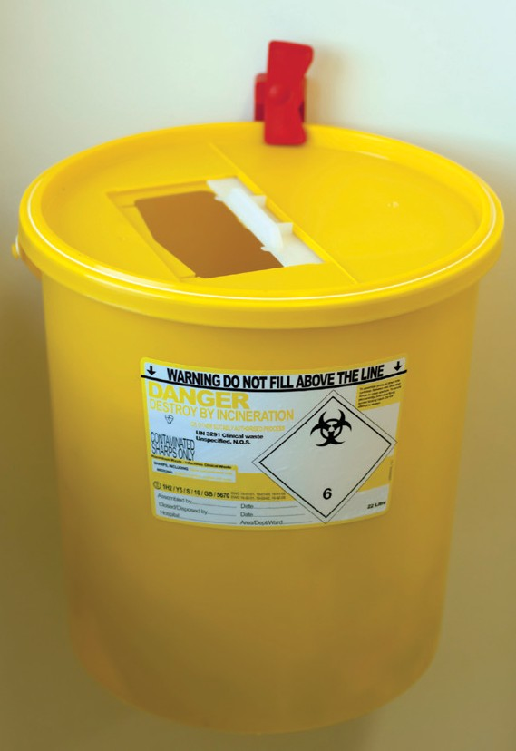

###### COP

The sharps box must comply with BS 7320 and UN 3291 and have the appropriate colour sharps box lid – orange for sharps derived from cosmetic piercing / tattooing procedures.

The details requested on the front of the sharps box should be completed before using. This is so that the source can be tracked if there is a problem after collection.

Ensure that the sharps box is correctly assembled before you start using it.

Sharps boxes must never be placed on the floor, or left in an area where clients may have open access to them.

Sharps boxes should not be stored on window sills or uneven surfaces– they should be stored on a level surface or on a wall bracket close to the operator. Sharps boxes should be available at all locations where sharps are used.

Devices should be assembled and disassembled with care. Needle bars and needles should not be separated – dispose of as a complete unit. Do not re-sheath/recap used needles/razors.

Use the temporary closure device on sharps boxes between uses and never move an open sharps box.

Never try to retrieve items from a sharps box.

Sharps boxes should be handled with the lid in the “closed” position to avoid accidental spillage of the contents, and held away from the body.

Don’t try to press sharps down into the container to make more room. When the container reaches the fill line, it should be locked. If the sharps container becomes damaged, place it inside a larger sharps container. Do not place inside a waste bag.

Before collection, sharps boxes should be stored in a locked area inaccessible to members of the public or unauthorised personnel.

Sharps boxes must be collected regularly by licensed contractors and sent for incineration.

If staff are unsure about the correct use of sharps boxes, the company representatives selling them are usually willing to give training when necessary.

# Dyes/pigments

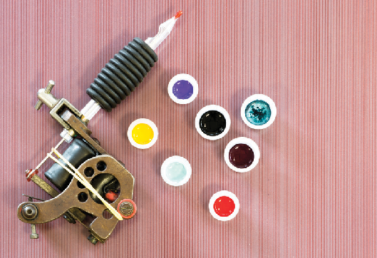Any ink products used for tattooing or semi-permanent skin colouring must be sterile and inert at first use.

Quality control during the manufacture and packaging of pigments and inks is important, because the products are intended for injection into the lower layers of

the skin, known as the dermis. This lower skin layer contains blood vessels and nerve endings – so injected material needs to be sterile to prevent infection. Poor quality tattoo inks increase the potential for localised bacterial skin infections as well as skin allergies following tattooing treatments.

Assess your product needs and avoid large orders. Buy smaller bottles of ink/pigment for colours that are not used so quickly. Once containers are opened there is a risk of air-borne contaminants such as bacteria and fungi. Never use a product beyond its use-by date.

***COP***

All dyes or pigments used for tattooing, micro-pigmentation and semi-permanent tattooing should be bought from reputable suppliers, and should be supplied with hazard data sheets, which is a fundamental requirement to ensure that, as far as possible, the appropriate quality tests have been undertaken and passed for the ink. Practitioners should request this information from their supplier if it is not provided. Practitioners should make a note of the batch numbers and delivery dates, if not already provided by the supplier.

Fresh pigments from a clean container should be used for each customer. The containers used to hold the dyes or pigments for each customer should be single-use and stored in an air-tight container and should be disposed of after each client.

# Blood/body fluid spillages

Blood and body fluid spills must be dealt with quickly and effectively. Specialist body fluid spill kits are available to purchase, but expiry dates of products should be checked regularly. A body fluid spill kit should contain disposable aprons and gloves, disposable cloths, general purpose detergent and chlorine granules.

***REG***

Risk assessments must be carried out on all hazardous substances used at work; this includes detergents, disinfectants and body fluids (e.g. blood). Blood and body fluids are included because of the potentially harmful micro-organisms they could contain.

This is a legal requirement of the Control of Substances Hazardous to Health Regulations (COSHH) 2002.

##### Cleaning a blood spillage

###### COP

* + Prevent access to the area containing the spillage until it has been safely dealt with.
  + Obtain a chlorine based spill kit.
  + Wear disposable gloves and an apron. Also consider, if there is a large spill, whether eye protection should be worn.
  + Apply disinfectant granules to the spill. This congeals the spill to enable easier cleaning of the area. Alternatively, make up and use the disinfectant solution to a dilution of 10,000ppm available chlorine. Leave in place for the designated exposure time (at least two minutes). Ensure the surface can tolerate chlorine.
  + Never mix chlorine-based products with other cleaning products or disinfectants.
  + Use the scoop and scraper (or paper towels) to pick up the spill and place in the appropriate waste bag.
  + Wash hands and put on new gloves.
  + Use disposable paper towels and disinfectant solution to clean the area thoroughly and dry afterwards.
  + All equipment, gloves and apron should also be disposed of in the waste bag.
  + Ensure that the waste bag is stored in the appropriate container immediately after use.
  + Wash hands.
  + Mop the affected area, and only ever use mops after all the above steps have been completed.

##### Contaminated clothing

Any contaminated clothes should be handled as little as possible and then only with gloves on. They should be washed as soon as possible on a hot cycle (60˚C or 90˚C), or discarded as clinical waste.

##### Cleaning vomit or urine spills

The same process can be followed as for blood fluid spills, but chlorine-based disinfectants mixed with acidic substances may cause chlorine gas to be released. The chlorine-based disinfectant should be replaced with a non-chlorine based product. A chlorine-based disinfectant can be used to disinfect but only after the spill has been cleaned up.

# Uses of sodium hypochlorite (bleach) and strengths of solution

Guidance on the use of sodium hypochlorite and the recommended strengths is shown below:

|  |  |  |  |
| --- | --- | --- | --- |
| **Use** | **Dilution of stock solution (%)** | | **Available chlorine (ppm)** |
| Blood spills | 1 in 10 | 10 | 10,000 |
| Environmental disinfection hard surfaces | 1 in 100 | 1 | 1,000 |

Undiluted commercial hypochlorite (bleach) solutions contain approximately 10% available chlorine.

Hypochlorite concentration is expressed in terms of parts per million (ppm) available chlorine. This varies from brand to brand and also depends on how the product has been stored. Liquid bleach should be stored in a cool, dark place and used within six months of purchase.

Chlorine-releasing agents should not be diluted in hot water, nor mixed with acids nor inappropriate cleaning solutions, as a rapid release of chlorine may occur, causing irritation to the eyes and respiratory tract of the user. Hazard safety data sheets are available on request from the manufacturer.

1. Needlestick injury or exposure to blood or body fluids

All needle-stick injuries (i.e. when the skin is pierced by a used, sharp instrument or piece of equipment), or splashes to the eyes, mouth, or an exposed area of broken skin, must be treated extremely seriously and urgent action taken. You must do this even if the instrument or piece of equipment looks clean.

If the injury has happened during the cleaning of equipment, it must be treated as a needle-stick injury. This is because there is still a risk of contamination with potentially harmful micro-organisms until the equipment has been sterilised.

First Aid following exposure:

1. Any wound should be made to bleed under clean running water – squeeze the area gently to do this, and wash with mild liquid soap. Do not suck the wound.
2. If eyes are involved, wash thoroughly with clean, running water for 5-10 minutes. If you have sterile eye wash solutions in your first aid kit, use this to flush the eyes.

If the mouth is contaminated, rinse with plenty of water.

1. Cover the wound with a clean dressing.
2. Seek advice/medical attention immediately at a local Emergency Department, ideally within one hour of the injury/incident occurring, and no later than 72 hours.
3. If you can safely do so, take the needle/instrument involved to the Emergency Department, and the name of the client involved.
4. If there is considerable contamination of unbroken skin, remove contaminated clothing and wash all affected thoroughly with water.
5. Record the accident/incident in the accident book.

Go to the nearest hospital accident and emergency department immediately in case further treatment is needed. Treatment started within one hour of the injury can be effective in protecting against HIV.

This course of action must be followed even if you have had hepatitis B vaccination. Remember, there is no vaccine available against hepatitis C and HIV.

For further guidance on Vaccinations, refer to Appendix 8.

***REG***

Inform the owner, manager or supervisor about the incident, which must be logged in the accident book. If an infection occurs as a result of the incident, it must be reported by completing the form on the HSE RIDDOR website. [*http://www.hse.gov.uk/riddor/report.htm*](http://www.hse.gov.uk/riddor/report.htm)

All incidents can be reported online but a telephone service remains for reporting fatal and specified injuries only – call the Incident Contact Centre on 0845 300 9923 (opening hours Monday to Friday 8.30am to 5pm).

# Disposal of waste

Waste should be segregated at the point of origin. Waste contaminated with body fluids is classified as “hazardous” or “offensive” waste, where it is generated in quantities of one 7kg bag or more in any one collection period. This includes contaminated gloves, aprons, swabs, cotton wool and paper roll.

Sharps should always be handled and disposed of as hazardous waste.

***COP***

Offensive waste must be disposed of into appropriately marked yellow/black waste bags (compliant with BS EN ISO 7765:2004 and BS EN ISO 6383:2004), which should be removed by an authorised contractor and taken for incineration at regular intervals. Before collection, offensive/hazardous waste bags should be stored in a locked area inaccessible to members of

the public or unauthorised personnel. The practitioner is responsible for ensuring that contracts are in place for collection and safe disposal of hazardous waste from the premises. It is essential to ensure with the waste management provider that appropriate documentation is generated when necessary and monitor the performance of staff and waste contractors as per the agreed contract.

###### COP

##### Handling of Clinical Waste

* + Use foot-operated pedal bins to hold the hazardous and non-hazardous waste bags in the treatment area. This is to prevent cross-contamination and to ensure proper segregation of waste.
  + Wear personal protective clothing when handling waste.
  + Remove the yellow bag when ¾ full.
  + Seal the bag securely and mark with the ‘point of origin’ label/tag prior to disposal, so that the source can be tracked in case of any problem after collection.
  + Store in a labelled, lockable, vermin-proof enclosure for collection.
  + If the exterior of the bag becomes contaminated or the bag splits or leaks, it should be double-bagged.
  + Waste should not be decanted into other bags, regardless of volume, should not be decontaminated on the outside or re-used.
  + Sharps must be disposed of into approved sharps containers (compliant with BS 7320/UN 3291).
  + Sharps/sharps containers should NEVER be placed into any waste bag.
  + Clinical waste should be collected regularly by a licensed waste management contractor.
  + All other waste can be disposed of as non-hazardous waste, being discarded into non- hazardous waste bags that go to landfill for disposal.

A copy of the current contract for the removal of such waste and contractor’s license and transfer notes must be available for inspection on the premises at all times. Premises producing over 200kg of hazardous waste per annum may need to be registered with the Environment Agency – discuss this with your local authority.

PLEASE NOTE: Full guidance relating to healthcare waste, including waste from skin piercing premises, is given in a Department of Health guide: Safe management of healthcare waste, which can be downloaded from the Department of Health website.

Your waste contractor should supply you with a normal duty of care note for collections. It should include the EWC 20 01 99 code and a reference to the H9 code which indicates that it must

be subject to alternative treatment (e.g. autoclave or incineration). Working with your suitably registered waste carrier will ensure compliance – they will be able to provide you with details of what information they require and how they require this.

***REG***

From January 2014 you must register as a waste carrier if you transport waste as part of your business. You can be fined up to £5000 if you don’t register.

To register as a waste carrier please visit the following website: h[ttps://w](http://www.gov.uk/waste-)ww.gov[.uk/wast](http://www.gov.uk/waste-)e[-](http://www.gov.uk/waste-) carrier-or-broker-registration.

# Ear-piercing

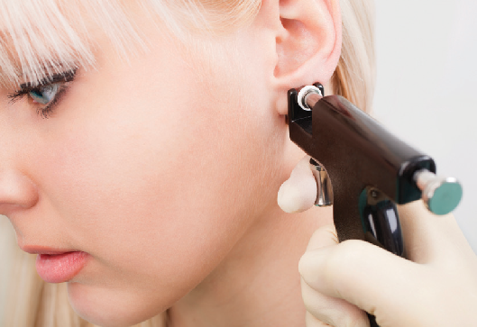This section deals primarily with ear-piercing using hygienic ear-piercing guns. Other sections cover hygienic procedures that should be read in conjunction with this section, for example, hand washing, customer care and record keeping.

Problems have arisen not only from unhygienic practices during this operation, but from the adverse effects of unsuitable materials remaining in close contact with body fluids. It is most important that earrings are

made of suitable materials, for example gold, platinum, titanium alloy (such as G23) or surgical stainless steel.

***COP***

Pens used to mark the ear should be single-use only, or a single-use toothpick dipped in gentian violet (also refer to section 6, ‘Skin preparation before a skin piercing procedure’).

Do not use ear-piercing guns for any other parts of the body other than the ear lobe (unless specified by the manufacturer). In most cases, such equipment is designed for the ear lobe only and the guns will become contaminated by inappropriate use elsewhere. The guns can also cause tissue damage if incorrectly used, or result in jewellery embedding, if the jewellery used is too small.

Ear-piercing may also be undertaken by use of traditional body piercing techniques.

# Cosmetic Body Piercing

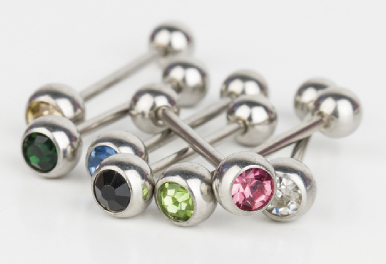It is vitally important to ensure that the jewellery is safe to use. Careful and thorough preparation of the jewellery begins before it reaches the studio. Choose a reputable manufacturer that can provide documented evidence

of the metals used to ensure that the jewellery complies with the nickel directive. Where practitioners cannot prove that jewellery being used complies with these requirements, it is advised that use of that jewellery stops until the practitioner can obtain evidence from the manufacturer of its compliance.

When received, jewellery should be stripped, decontaminated, rinsed, ultrasonically cleaned, rinsed and sterilised. Jewellery for sale should also be processed to ensure that no contaminants are present (such as surface polishes).

Prior to piercing, practitioners should always use consent forms and medical history forms. This measure protects both parties. The procedure should be explained so that the client is aware of the implications of being pierced. Refer to Section 4, ‘Customer Care and Record Keeping’.

The client should be encouraged to come back in after a set period of time to check on the healing process. Aftercare instructions should be given both in writing and verbally to ensure that the client is aware of their responsibility to care for their new piercing.

# Mobile/home working

All mobile/home workers must be registered with the local authority (where applicable), in the borough in which they will be practising.

Equipment used and standards maintained must match those required in a treatment room/ studio in accordance with the relevant Regulations and Codes of Practice (for example, hand- washing facilities with hot and cold running water, clean and dirty areas, decontamination and sterilisation etc). If this cannot be achieved, then mobile/home visits should not be carried out.

Additional measures to be considered may include drainage and transportation of clinical waste and sharps.

All facilities must be connected to a sewer or have a waste water storage tank suitable for the reception of all liquid wastes arising from the premises. Waste water storage tanks must be discharged to the sewer.

There must be suitable facilities for storage of equipment and clinical waste, before and after use, and during transport. Adequate procedures must be in place for handling of all waste and contaminated equipment.

# Insurance

The business must have employer’s liability insurance where appropriate and ideally should have third party liability insurance to cover claims, damages or negligence.

# Legal references – list

* Byelaws, made under Local Government (Miscellaneous Provisions) Act 1982, as amended by the Local Government Act 2003;
* London Local Authorities Act 1991;
* Health and Safety at Work etc Act 1974;
* Control of Substances Hazardous to Health Regulations 2002;
* Personal Protective Equipment Regulations 2002;
* Tattooing of Minors Act 1969;
* The Prohibition of Female Circumcision Act 1985;
* Pressure Systems Safety Regulations 2000;
* The Medicines Act 1968;
* Environmental Protection Act 1990 and Waste Management Licensing Regulations 1994 (clinical waste);
* Offences Against Persons Act 1861;
* Smokefree (Premises and Enforcement) Regulations 2006.

Appendix 1:

Guidance on the Health Questionnaire

Some prospective clients could have a medical condition that places them at greater risk of complications, should they choose to have a skin piercing treatment.

**Congenital (present from birth)** and other heart defects make it much more likely that a blood infection could cause serious heart complications.

**High/Low Blood Pressure** - can cause light-headedness and be linked to heart circulation disorders.

**Heart Disorders** – some heart defects render individuals more prone to serious heart complications from blood infections.

**Pregnancy and nursing mothers** – the immune response can be affected by pregnancy, and any infection could affect the unborn child.

**Epilepsy** – if the condition is not properly under control, fitting could occur during treatment. Medication used to treat the condition can also cause side effects.

**Diabetes** – long term sufferers may have circulatory problems which can reduce the skins ability to heal. This can lead to an increased risk of infection.

**Known allergy to certain products** - (e.g. disinfectants, latex and trace metals) can result in a serious reaction, sometimes from minute amounts of a substance.

**Eczema and psoriasis** - can make a person prone to skin infections/irritation.

**Blood clotting disorders** - or medication that affects coagulation may result in poor healing after even the slightest skin breakage.

**Blood borne viruses** - can be spread if stringent hygienic work practices are not followed.

**Autoimmune disease/other immune deficiency** - can make a person more prone to serious infection.

**Drugs and alcohol** – treatment cannot be undertaken if the client is under the influence of any substances that can impair their decision making abilities. Alcohol also thins the blood and increases bleeding time.

**Medication** can cause side effects that affect healing and recovery from treatment. As well as obtaining relevant medical information from your prospective client, the client should give written consent to a specified procedure. If you have any concerns about your client’s medical condition, you should refuse to carry out the procedure and advise them to contact their GP.

The above list is not exhaustive and the client should inform the operator if they are suffering from any other medical condition as it may be relevant to the treatment being provided.

Under the Data Protection Act 1998, any information of a sensitive or personal nature that you request and record, from your clients must be stored securely under lock and key. The information must not be used for any purpose other that that indicated to the client i.e. only for ensuring that the proposed treatment is safe based on the information provided in the health questionnaire.

You must make sure that your client knows who is obtaining the data, for what purpose and for how long the information will be kept. It is recommended that any data collected be stored for seven years from the date when the treatment is completed. Please check with your local Environmental Health Officer as requirements may vary in different areas.

Client consent form and health questionnaire

|  |  |
| --- | --- |
| Name of premises: | |
| Address of premises: | |
| Name of practitioner: | |
| Client name: | |
| Client address: | |
| Tel no: | |
| Date of birth: | |
| Proof of age (if app): YES / NO | Details: |

|  |  |
| --- | --- |
| Medical history | If YES, give details: |
| Allergies | YES / NO |
| Medication (e.g. antihistamines, steroids, aspirin) | YES / NO |
| Diabetes | YES / NO |
| Epilepsy | YES / NO |
| Haemophilia/other clotting disorder | YES / NO |
| Heart condition | YES / NO |
| Hepatitis / HIV | YES / NO |
| High/low blood pressure | YES / NO |

|  |  |
| --- | --- |
| Immuno-compromising condition | YES / NO |
| Implants | YES / NO |
| Pregnancy/breastfeeding | YES / NO |
| Skin condition/infection/keloid scarring | YES / NO |
| Any other current medical condition | YES / NO |
| Treatment details: *Please insert the treatment & site of procedure, & design/materials used (if appropriate) | |
| Client information:  Certain treatments can result in the following complications:   * Scarring * Blood poisoning (septicaemia) * Jewellery embedding / migration * Localised infection – particularly nose, navel and genitals * Localised swelling and trauma around the site * Allergic reactions * Tongue piercings can lead to swelling, choking and restriction of the airway and gum / tooth damage | |
| I confirm that I give my full consent to the treatment being carried out. I confirm that potential complications for the procedure being carried out and aftercare instructions have been explained to me. A written aftercare advice sheet has been given to me. I confirm that the above information provided by me is correct, and that I am not currently under the influence of alcohol or drugs.  Signature: Date:  Client / Parent or Guardian*  *Delete as applicable | |
| Practitioner’s Signature: Date: | |
| Appropriate aftercare sheet given YES / NO | |

Appendix 2:

Aftercare follow-up – Evaluation sheet

Name of client:

|  |  |  |  |
| --- | --- | --- | --- |
| Date & time | Description/ Problem | Action taken/ Advice given | Signature of practitioner |
|  |  |  |  |
|  |  |  |  |
|  |  |  |  |
|  |  |  |  |
|  |  |  |  |
|  |  |  |  |
|  |  |  |  |
|  |  |  |  |
|  |  |  |  |
|  |  |  |  |
|  |  |  |  |
|  |  |  |  |
|  |  |  |  |

Appendix 3: Aftercare of the client

Clients should be advised to maintain a good standard of personal hygiene to avoid the introduction of potentially harmful micro-organisms (germs) into the body’s tissues. Written aftercare information should be provided to reinforce verbal advice, and the client should be encouraged to come back if there are any issues with healing. Any follow up visits should be recorded.

In the case of piercing or treatments carried out on minors, a parent or other responsible adult must be present when aftercare advice is given.

Aftercare sheets are available to download:

* Tattoo
* Ear and face piercing
* Oral piercing
* Body and surface piercing
* Genital piercing (female)
* Genital piercing (male)
* Microdermal implants

from [http://www.cieh.org/WorkArea/showcontent.aspx?id=47704.](http://www.cieh.org/WorkArea/showcontent.aspx?id=47704) Go to PART C, Leaflets 01 to 07

When checking the site, hands should be clean. It is not normally necessary to turn a piece of jewellery but if the client has been advised to do this, it should be handled as little as possible, using a clean tissue to touch the jewellery.

When salt water is recommended for use to clean a site, it should have been boiled and allowed to cool before use. Sterile salt water (e.g. Normasol) can be bought from chemists for this purpose.

When covering tattoos, it is good practice to use a sterile non-adhesive gauze, secured with hypo- allergenic tape, or a sterile non-adhesive dressing for larger areas. If plastic film wrap is used, it must be clean (taken directly from the pack), and the client should be advised on how and when to replace this covering. In many cases, simply keeping the area clean and dry is likely to be the best approach.

If any of the following signs or symptoms are seen, urgent medical attention should be sought:

* Redness spreading around the site and extending away from it;
* Pus or green/yellow fluid oozing;
* Bleeding that is not controlled by light pressure;
* Pain (rather than discomfort);
* Swelling;
* Heat;
* Immobility of, or reluctance to move, a limb/digit/part of the body.

The procedure site should be kept clean and dry to promote healing.

For body piercing, it is difficult to estimate the expected healing times since individuals heal at different times.

Clients should be advised about healing times, which may be prolonged because of the time it takes for the jewellery “tunnel” to become dry and healed after the initial tissue damage.

The Tattoo and Piercing Industry Union indicate the following possible healing times:

|  |  |
| --- | --- |
| **Part of body** | **Healing time** |
| Ear lobe, eyebrow, nasal septum | 4 - 8 weeks |
| Ear (cartilaginous region), nostril | 2 months - 1 year |
| Tongue | 3 - 6 weeks |
| Lips, cheeks | 4- 12 weeks |
| Genitalia including inner labia, clitoral hood | 3 - 12 weeks |
| Nipple, scrotum, outer labia | 2 - 6 months |
| Navel, ampallang (transverse penile piercing) | 2 months - 1 year |

Appendix 4: Use of local anaesthetic agents

Topical local anaesthetic products for surface (skin) anaesthesia are available from pharmacies, however none of these products are licensed for local anaesthesia prior to tattoo or piercing procedures. Any purchase or application of a local anaesthetic product should remain with the client.

The client should be advised to read the Patient Information Leaflet accompanying the product and should be aware of the following:

* + Warnings, cautions and contraindications
  + Side effects
  + That they are using the product for an unlicensed indication
  + Recommendations regarding administration and application.

Local anaesthetic injections are prescription-only medicines (POMs) and can therefore only be prescribed by a suitably qualified practitioner, and are not licensed for local anaesthesia prior to tattoo or piercing procedures.

# Appendix 5: Hand hygiene

Hand washing is the single most important measure in reducing the spread of disease. Hands are a recognised principle route of cross infection. A liquid soap is recommended for hand washing. Alcohol / sanitising rubs are not an alternative to hand washing prior to invasive procedures, such as any skin piercing process.*

*Alcohol / sanitising hand rubs (cleanser) are not effective against spore forming pathogens and some other viruses (due to insufficient contact time). In addition, they are only effective on hands that are already visibly clean (free from dirt and organic material).

To ensure that hands are washed thoroughly ensure that the hand washing technique on the next page is followed. The process takes 15 – 30 seconds for normal hand washing:

1. Remove all wrist and hand jewellery and cover cuts and abrasions with waterproof dressings. Fingernails should be kept short, clean and free from nail polish. Before washing your hands, wet them under running water.
2. Apply sufficient liquid soap to obtain a good lather. The hand wash solution must come into contact with all of the surfaces of the hand. Rub hands together vigorously for at least 10-15 seconds, paying particular attention to the tips of the fingers, thumbs, backs of hands and the areas between the fingers. Hands should be rinsed thoroughly.
3. Dry hands with soft paper towels and throw away into a foot-operated waste bin. Hands should not be used to lift the lid or they will become recontaminated.

After washing your hands, rinse them under running water to remove all the germs loosened during hand washing, then dry your hands thoroughly on paper towels, ideally from a wall mounted towel dispenser.

Hand washing must be done at the following times:

* Before and after carrying out a skin piercing procedure;
* Before and after eating and drinking;
* After using the toilet;
* After smoking;
* After accidental contamination of hands with body fluids;
* If hands are visibly dirty;
* Before putting on gloves at the start of a procedure;
* After taking off gloves and apron at the end of a procedure;
* If gloves are removed during a procedure (e.g. to get more equipment) hands must be washed then, and again before putting on a new pair of gloves to resume the procedure.

The wearing of rings (other than a plain wedding band), wrist watches or wrist bands is not advised while carrying out skin piercing procedures because it is not possible to wash the hands thoroughly up to the wrists.

A poster showing the technique for safe removal of disposable gloves can be downloaded from the following website:

[*http://www.cieh.org/WorkArea/showcontent.aspx?id=47704*](http://www.cieh.org/WorkArea/showcontent.aspx?id=47704)

**How to Handwash?**

### WASH HANDS WHEN VISIBLY SOILED! OTHERWISE, USE HANDRUB

#### E Duration of the entire procedure: 40-60 seconds

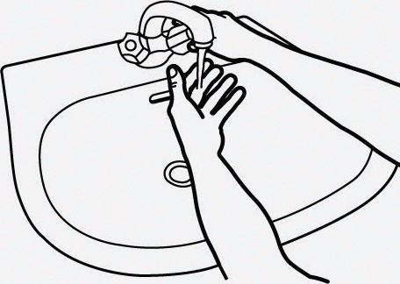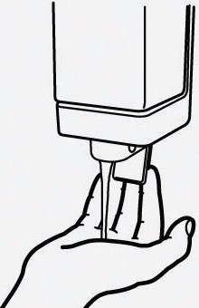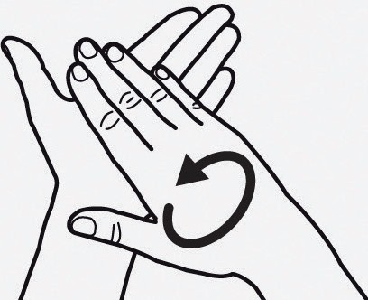**m D**

Wet hands with water;

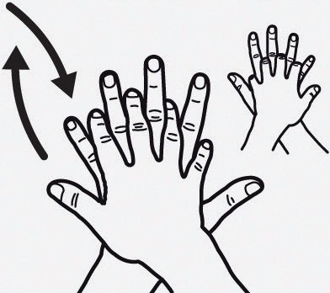

Right palm over left dorsum with interlaced fingers and vice versa;

Apply enough soap to cover all hand surfaces;

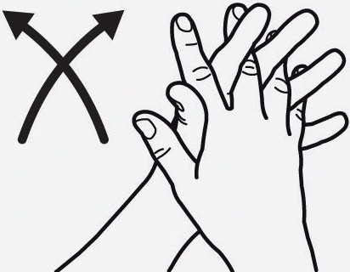**El**

Palm to palm with fingers interlaced;

Rub hands palm to palm;

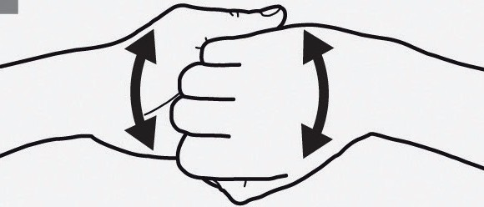

Backs of fingers to opposing palms with fingers interlocked;

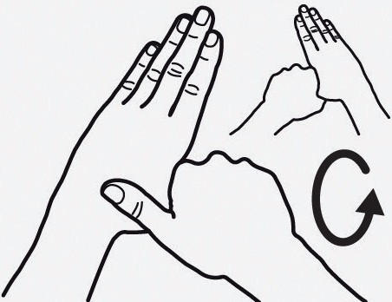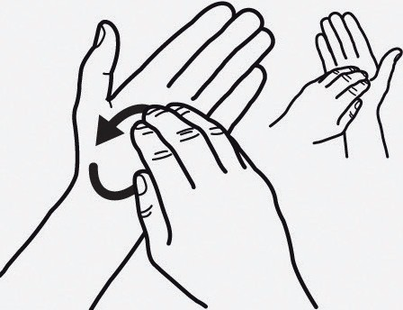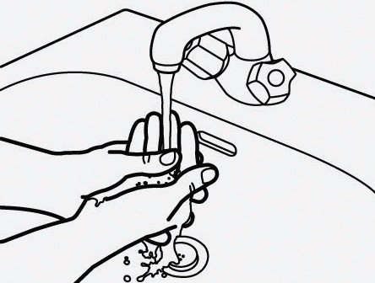**m m**

Rotational rubbing of left thumb clasped in right palm and vice versa;

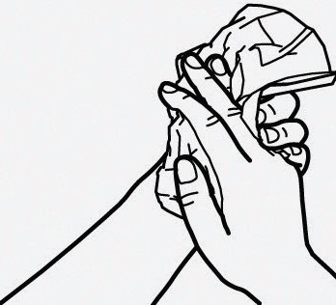**m**

Dry hands thoroughly with a single use towel;

Rotational rubbing, backwards and forwards with clasped fingers of right hand in left palm and vice versa;

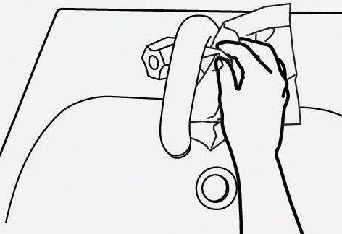**mJ**

Use towel to turn off faucet;

Rinse hands with water;

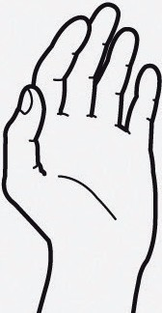**m**

Your hands are now safe.



May 2009

Appendix 6:

Chemical cleaning and disinfection

Common cleaning agents/disinfectants and their appropriate uses:

|  |  |  |  |
| --- | --- | --- | --- |
| **Cleaning agent** | **Instruments** | **Skin** | **Work surfaces** |
| **Powder or liquid detergent** diluted in hot water as indicated by the manufacturer – this is a cleaning agent, not a disinfectant | Yes – can be used for initial cleaning of instruments prior to  disinfection or steam sterilisation | No | Effective for cleaning down surfaces at end of sessions/  day, prior to surface disinfection |
| **Disinfectant** | **Instruments** | **Skin** | **Work surfaces** |
| **Bleach** – hypochlorite – on application bleach products must contain minimum 1000ppm available chlorine, e.g. from sodium hypochlorite solution or other source of chlorine such as sodium  dichloroisocyanurate (NaDCC) soluble tablets | No | No | Yes (hard, man made work surfaces)  Corrosive – not for jewellery |
| **60 – 80% alcohol** available as a component of disinfectant spray or 60-70% alcohol wipes | No | Yes | Yes, but effect is greatly reduced by any soiling |
| **Halogenated Tertiary Amines and quaternary ammonium compounds** (e.g Trigene); these products are often available as a spray, ready to use bulk solution, powder or wipes | Yes – but some products may damage metal surfaces with lengthy exposure | No | Yes |
| **Chlorhexidine** based products – often combined with alcohol eg Hibisol. Sachets should be individually packed to prevent contamination | No | Yes | No |
| **Glutaraldehyde** based products such as Omnicide | This substance cannot be used on skin and is both an irritant and a potent allergen. Exposure to it is strictly controlled under COSHH. Its use cannot be recommended unless appropriate exposure control measures are in place. | | |
| **Phenolic** based products such as Hycolin, and related products such as Stericol and Clearsol | These products contain 2, 4, 6-trichlorophenol and or xylenol, and these chemicals were not supported  under a recent biocides review. As such these products can no longer be supplied or used for any application, and were never appropriate for use on skin. | | |

The term **sterilant** is sometimes used by chemical manufacturers to describe chemical products that can kill many harmful microorganisms, including spores. Although a sterilant may be capable, under certain carefully controlled conditions, of producing sterility, such products should only be regarded as disinfectants.

# Appendix 7: Example maintenance record sheet

AUTOCLAVE DAILY RECORD SHEET

Copy form for use

Please keep these records in date order for inspection

|  |  |  |  |  |  |  |  |
| --- | --- | --- | --- | --- | --- | --- | --- |
| Autoclave reference number: | | | | | | | |
| Week commencing: | | | | | | | |
| Daily test | Mon | Tue | Wed | Thu | Fri | Sat | Sun |
| Cycle counter number (if available) |  |  |  |  |  |  |  |
| Time to reach holding temperature |  |  |  |  |  |  |  |
| Temperature during holding period |  |  |  |  |  |  |  |
| Pressure during holding period |  |  |  |  |  |  |  |
| Total time at holding temp/ pressure |  |  |  |  |  |  |  |
| Test strip attached |  |  |  |  |  |  |  |
| Initials of authorised user |  |  |  |  |  |  |  |

|  |  |  |
| --- | --- | --- |
| Weekly test: | Yes/No | Comments |
| Door seals secure |  |  |
| Door safety devices functioning correctly |  |  |
| Safety valves operating correctly |  |  |
| Comments | | |
| Name | Date | Signature |

# Appendix 8: Vaccinations

Refer to department of Health Guidance h[ttp:/w](http://www.dh.gov.uk/en/Publichealth/Immunisation/)ww[.dh.go](http://www.dh.gov.uk/en/Publichealth/Immunisation/)v[.uk/en/Publichealth/Immunisation/](http://www.dh.gov.uk/en/Publichealth/Immunisation/) Greenbook/index.htm

##### Hepatitis B vaccination

All operators who could come into contact with blood or body fluids, or who use or handle sharp instruments, should have a course of hepatitis B vaccination (HSE 2001, DH 2006).

An accelerated course consists of three doses at zero, one and two months, followed by fourth dose at twelve months, with a blood test to check levels one to four months after the completion of the primary course.

The DH now recommends that all individuals at continuing risk of hepatitis B infection should have a booster five years after the primary course. There is no need for a blood test at this time.

A hepatitis B booster may be recommended after exposure to the hepatitis B virus (e.g. sharps’ injury).

Hepatitis B vaccination can be organised through your GP. You may have to pay for the vaccination, however if you are employed, your employer should pay for it.

Keep a record of the dates of vaccination and the results of future tests to check whether or not you have an adequate level of protection against hepatitis B and whether or not a booster is needed (this will be indicated on the test reports to your GP).

There are currently no vaccines available against hepatitis C or HIV.

If a practitioner is found to be positive for a blood borne virus disease, they should be assessed and advised by their GP in relation to working practices.

##### Tetanus vaccination

All individuals handling sharps are advised to ensure they are up-to-date with tetanus vaccinations. Your GP will be able tell you whether or not you are fully protected against tetanus.

*Photo credit throughout this document: Thinkstock*

