THE TAKING CONTROL OF GOODS (FEES) REGULATIONS 2014

IMPORTANT If your case is passed to the Enforcement Agents for collection, you will have to pay additional fees, as shown below:-

SCHEDULE Regulation 4
Fees recoverable under regulation 4

Table 1
Enforcement other than under a High Court Writ
Fee Stage | Fixed Fee | Percentage fee (regulation 7): percentage of sum be recovered exceeding £1500 | to
Compliance stage | £75.00 | 0%
Enforcement stage | £235.00 | 7.5%
Sale or disposal stage | £110.00 | 7.5%

FIN/ABEA 2014 Feb 2014

TONBRIDGE AND MALLING BOROUGH COUNCIL

Action by Enforcement Agents

Council Tax Office

Tonbridge and Malling Borough Council Gibson Building
Gibson Drive Kings Hill West Malling Kent

ME19 4LZ
Tel: (01732) 876388

Email: revenues@tmbc.gov.uk
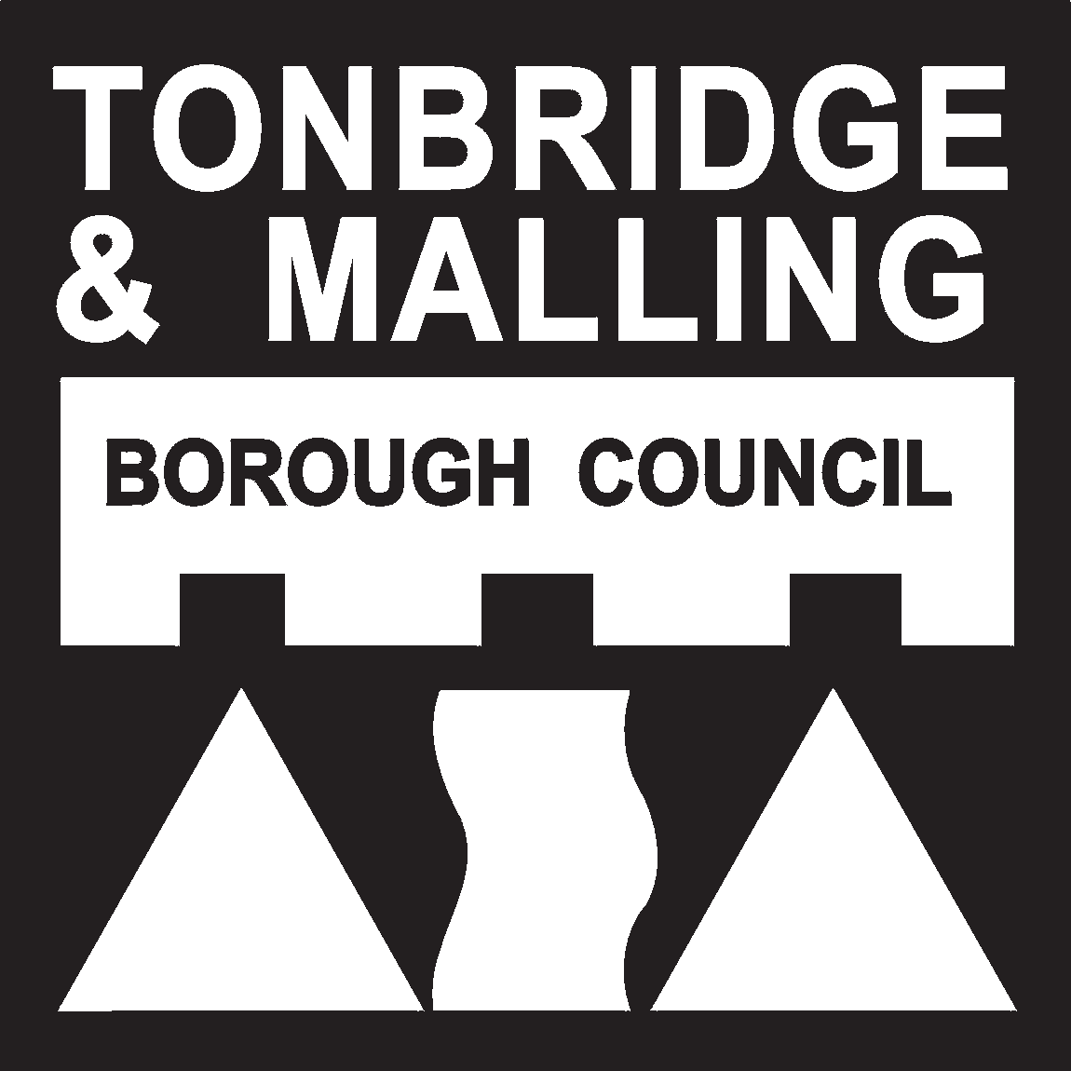

Why do we use enforcement agents?
The Council has a legal duty to collect unpaid council tax as promptly as possible. If we allow arrears to build up it may mean that the council tax has to be increased in future to make up for it.
After we have taken a person to court, we have a number of legal powers which we can use. In each case, we must decide which power is most appropriate. In many cases, however, we have no alternative other than to use enforcement agents. Enforcement agents used to be called bailiffs.

Who are the enforcement agents?
The Council employs external enforcement agents. The enforcement agents are certificated by a competent court.

What can the enforcement agents do?
The enforcement agents have the power to take control of goods. This means that they can seize your possessions and sell them to raise enough money to pay off the outstanding council tax. They will also need to cover their own fees.
To start with, the enforcement agents write to you and charge a “compliance fee” of £75. It is very important that you do not ignore the enforcement agents letters. If you do, you might end up having to pay extra fees to them.

Can the enforcement agents seize all my possessions?
There are some items which enforcement agents may not legally seize. These include cookers and fridges (unless you have more than one), and certain tools or equipment that you use personally for your trade.

What are the enforcement agents’ fees?
If your case is passed to the enforcement agents, you will have to pay their fees. The fees are laid down in law, and the amounts are set out on the back of this leaflet.

What should I do if my case is passed to the enforcement agents?
The enforcement agents’ job is to collect the outstanding council tax as quickly as possible. Therefore, you should pay the outstanding amount, including any fees, to the enforcement agents immediately. Please do not send any payments direct to the Council in respect of the debt which the enforcement agents are dealing with.
If you're not able to pay the outstanding debt in full, the enforcement agents may agree to let you pay by instalments. However, this will be entirely at the
enforcement agents’ discretion. If the enforcement agents do agree to let you pay by instalments, they will usually want to enter into a “controlled goods agreement”, previously known as "walking possession". This means that they will legally take possession of your goods, but they will not remove them from your property as long as you make all the payments.

What happens if I can't afford to pay the enforcement agents, and I don't have many possessions either?
If the enforcement agents decide that it is impossible to recover the outstanding debt from you, they will return your case to us. We may then take your case back to court. The court will decide whether you have deliberately failed to pay your council tax, or if you have been neglectful. If so, the Court may send you to prison for 3 months.

What should I do if I have any queries?
If you have any queries about the Council Tax itself (for example, if you think that the amount in question has already been paid, or has been calculated wrongly), you should contact us (details on the front of this leaflet).
If you wish to discuss payment, or have any queries about the action being taken by the enforcement agents, please contact the enforcement agents direct.

What should I do if I have a complaint about the enforcement agents?
The enforcement agents are working on our behalf, so we are keen to make sure that they are acting correctly and providing a satisfactory standard of service.
For this reason, we have a code of conduct for enforcement agents. If you would like a copy, phone us on (01732) 876388.
If you have any complaints about the conduct or behaviour of the enforcement agents, please put your complaint in writing to the enforcement agents in the first instance. However, if you are still not satisfied with the enforcement agents response, please write to us at the address shown on the front of this leaflet.

What are my legal rights?
If you are unsure about your legal rights with regard to enforcement agents, you should seek professional legal advice. Alternatively, you should contact your local Citizens' Advice Bureau.

