**Woodland Walk**

**Halloween Trail Answer Sheet**

**Follow the trail through the woodland and discover some curious creatures and frightening fungi ! Finding the missing letter of each creature and fungi will spell out a spooky word. The answer will be found at the end of trail, by the play area in Frogsbridge Sportsground.**

**Please use this page to enter the missing letters and to see a description of the trail route and map.**

|  |  |
| --- | --- |
| **Letter 1** |  |
| **Letter 2** |  |
| **Letter 3** |  |
| **Letter 4** |  |
| **Letter 5** |  |
| **Letter 6** |  |
| **Letter 7** |  |
| **Letter 8** |  |
| **Letter 9** |  |
| **Letter 10** |  |



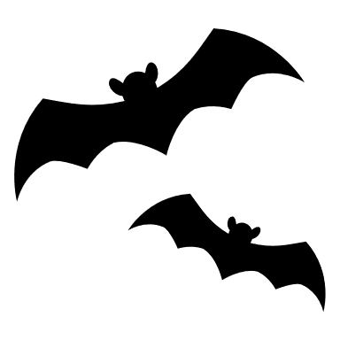





**Map of Halloween Trail**

**Description of the trail route**

* The route follows a lineal path, with a mixture of even pathways and uneven woodland trails. Both types of pathway are on flat terrain.
* Look out for curious creatures and frightening fungi signs and write down the missing letter in their name.
* The signs may not be in numerical order so look for the corresponding number on each sign to match with the letter on this worksheet.
* Start the trail at the Higham Lane entrance to Woodland Walk.
* Continue along the pathway, past the play area and across Romney Way and into the woodland.
* Follow the pathway through the woodland and around the outskirts of Hugh Christie School.
* Follow the pathway, where it emerges at Frogsbridge Sportsground, with the stream on your left.
* The trail finishes at the play area in Frogsbridge Sportsground, with the answers found attached to the play area, near the final trail marker.



